FINGERBOARDS MINERAL SANDS PROJECT

Risk treatment plan:
Environmental noise
EPA Update 9 July 2021

Notes:
- Base document is Tabled Document 201a (centrifuge changes – clean version).
- Comments / references provided in square brackets [xxx] for context.

Risk treatment plan: Environmental noise

Contents
1. Scope 2
2. Key sensitive receptors 2
3. Inherent risk 3
4. Objectives 4
5. Compliance standards 4
6. Acceptance criteria 5
7. Controls to address hazard 6
8. Residual risk assessment 10
9. Monitoring 11
10. Reporting 13
11. References 15
12. Kalbar reference documents 15

List of tables
Table 2-1: Key sensitive receptors - noise 2
Table 2-2: Sensitive receptor locations 1
Table 3-1: Inherent risk ratings – environmental noise 3
Table 6-1: Acceptance criteria – noise and vibration 5
Table 7-1: Environmental noise controls and associated performance measures 6
Table 7-2: Additional Controls identified in the EES process. 9
Table 8-1: Residual risk ratings – environmental noise 10
Table 9-1: Proposed monitoring for environmental noise 11
Table 10-1: Noise performance and compliance reporting 13
Table 12-1: Kalbar reference documents 15

List of figures
Figure 2.1: Sensitive receptor locations (dwellings) 2

Scope
This risk treatment plan is for the control of mining hazards associated with noise and vibration impacts. A ‘mining hazard’ means any mining activity that may pose a risk to the environment, to any member of the public or to land, property or infrastructure in the vicinity of work carried out within the Fingerboards mining licence area at any stage of project implementation (construction, operations, decommissioning and closure).
The noise controls described in this risk treatment plan apply to activities carried out within the Fingerboards mining licence area. Although some of the controls will also have the effect of limiting noise impacts of project-related activities beyond the mining lease (for example, transport of product by road), this plan does not specifically address noise or vibration generated outside the mining licence area. A Traffic Management Plan (insert document number when EMS numbering system is established) prepared as a requirement of the project’s Planning Scheme Amendment and Incorporated Document describes how off-mine noise and/or vibration impacts from project vehicles will be managed.
This risk treatment plan does not address occupational vibration exposures or noise exposures regulated under the Victorian Occupational Health and Safety Regulations 2017. This risk treatment plan does not include controls to address vibration from mining activities, as baseline modelling for the Fingerboards project (Marshall Day, 2019) has concluded that even under worst case conditions vibration from the all sources within the mining licence area is expected to be well within applicable guidelines and standard criteria ranges, such that special control measures are not required.

Key sensitive receptors
Key sensitive receptors include any member of the public, especially occupants of nearby dwellings, that may be impacted or incommoded by noise or vibration arising from mining activities within the Fingerboards mining licence area (Error! Reference source not found.). Kalbar has identified 49 residential locations in proximity to the mining licence area as sensitive noise receptors (Error! Reference source not found., Error! Reference source not found.). The properties at locations R2 and R3 are owned by Kalbar and will not be occupied during construction or operations. The property at location R4 is being used by Kalbar as a mine site office.
Table 2-1: Key sensitive receptors - noise
# | Details of sensitive receptor | Location and proximity to site | How hazard may harm / damage receptor | Evidence to support assessment
1 | Residential properties / accommodation near to mining licence area. | Refer Figure 1 and Table 2 | [EPA Comment: should properly refer to s 3, 25 and 166 of the New EP Act which apply to all noise. Also needs to refer to impact on environmental values referred to in the ERS]  Loss of amenity: exceedance of noise limits prescribed under the Environment Protection Regulations 2021 by reference to the Noise Protocol (note that ‘noise limit’ is a defined term under the Regulations).  Sleep disruption. | Marshall Day Acoustics, 2019. Fingerboards Mineral Sands: EES Noise and Vibration Assessment, report number 001 R07 20170182, 31 October 2019.
[EPA Comment: As above, should apply the ERS as well (which may result in additional locations where the environmental values are relevant)] The Noise limit and assessment protocol for the control of noise from commercial, industrial and trade premises and entertainment venues, EPA Publication 1826.4) (Noise Protocol), compliance with which is required by Part 5.3 (Noise) of the Environment Protection Regulations 2021, defines a ‘noise sensitive area’ as follows (rule 4 definitions):
“noise sensitive area means—
(a) that part of the land within the boundary of a parcel of land that is—
(i) within 10 metres of the outside of the external walls of any of the following buildings—
(A) a dwelling (including a residential care facility but not including a caretaker's house);
(B) a residential building;
(C) a noise sensitive residential use; or
(ii) within 10 metres of the outside of the external walls of any dormitory, ward, bedroom or living room of one or more of the following buildings—
(A) a caretaker's house;
(B) a hospital;
(C) a hotel;
(D) a residential hotel;
(E) a motel;
(F) a specialist disability accommodation;
(G) a corrective institution;
(H) a tourist establishment;
(I) a retirement village;
(J) a residential village; or
(iii) within 10 metres of the outside of the external walls of a classroom or any room in which learning occurs in the following buildings (during their operating hours)—
(A) a child care centre;
(B) a kindergarten;
(C) a primary school;
(D) a secondary school; or
(b) subject to paragraph (c), in the case of a rural area only, that part of the land within the boundary of—
(i) a tourist establishment; or
(ii) a campground; or
(iii) a caravan park; or
(c) despite paragraph (b), in the case of a rural area only, where an outdoor entertainment event or outdoor entertainment venue is being operated, that part of the land within the boundary of the following are not noise sensitive areas for the purposes of that event or venue—
(i) a tourist establishment;
(ii) a campground;
(iii) a caravan park;”
Accordingly, it can be seen that statutory noise limits apply to various forms of accommodation (including camping) and education uses. The most noise affected receivers from the Project are all residential dwellings. Therefore, whilst other types of receivers are considered ‘noise sensitive’ under the Regulations, compliance with noise limits at nearer receivers achieves compliance with noise limits at these more distant uses. [EPA Comment: Kalbar to confirm if any locations further away require compliance with lower limits?]
In addition to statutory noise limits set by the Regulations and Noise Protocol, Part 3 of the Environment Reference Standards made under s93 of the Environment Protection Act 2017 set indicators and objectives for various land use categories. In the case of the Project, Category IV applies to Farming Zone land and Category V applies to ‘natural areas’ such as Lympiars State Forest. [EPA Comment: should be amended to properly reflect the ERS. This jumps straight to the objectives and indicators in the ERS, but does not mention the environmental values, which are in fact the primary consideration (indicators and objectives are measures to understand / assess the risk to the environmental values). For matters regarding the ERS, there is relevant information in the recently released Guide to the ERS which may be of assistance to Kalbar (Pub. 1992, https://www.epa.vic.gov.au/about]
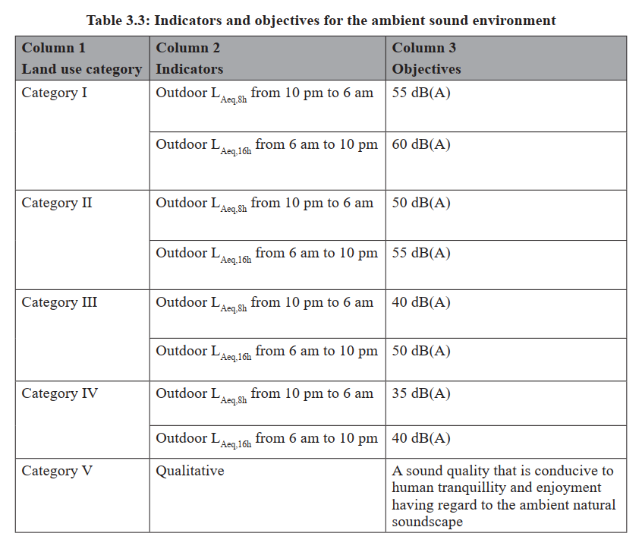
Figure 1 Extract from Environment Reference Standard
These objectives provide a context for this Project, although as the Preamble (clause 1) of the Environment Reference Standard states “This ERS is not a compliance standard. Its primary function is to provide an environmental Assessment and reporting benchmark.”
In some circumstances, noise can adversely affect native fauna by interfering with communication, masking the sounds of predators and prey, and cause stress or avoidance reactions. However, the mining licence area and most nearby surrounding areas are characterised by an agricultural landscape that has been extensively cleared of native vegetation, which has reduced the amount of available habitat. Current land uses may affect native fauna through the use of farm machinery and traffic noise associated with roads. A detailed ecological investigation (EHP, 2019) has concluded that native fauna species in the project locality are likely to habituate to noise from mining activities and continue to use the areas adjoining the mining licence area for foraging, roosting and/or breeding. Accordingly, native fauna have not been included as sensitive receptors in this risk treatment plan. A separate risk treatment plan has been prepared to address potential project impact on flora and fauna (Fingerboards Draft Biodiversity Risk Treatment Plan.
Table 2-2: Sensitive receptor locations
Receptor | To project area (km) | To mining activity (km) | Description |  | Receptor | To project area (km) | To mining activity (km) | Description
R01 | 0.14 | 0.76 | Residence |  | R29 | 1.09 | 1.50 | Residence
R02 | 0.16 | 0.18 | Residence (owned by Kalbar) |  | R30 | 0.33 | 0.35 | Residence
R03 | 0.00 | 0.00 | Residence (owned by Kalbar) |  | R31 | 0.59 | 0.61 | Residence
R04 | 0.00 | 0.12 | Residence (owned by Kalbar) |  | R35 | 1.36 | 1.65 | Residence
R05 | 0.26 | 0.36 | Residence |  | R36 | 1.04 | 1.14 | Residence
R06 | 0.58 | 0.84 | Residence |  | R38 | 1.94 | 2.12 | Residence
R07 | 0.22 | 0.32 | Residence |  | R40 | 1.83 | 2.03 | Residence
R08 | 1.70 | 1.94 | Residence |  | R41 | 1.34 | 1.55 | Residence
R09 | 1.92 | 2.06 | Residence |  | R42 | 1.42 | 1.72 | Residence
R15 | 0.27 | 0.53 | Residence |  | R43 | 1.51 | 1.66 | Residence
R16 | 0.94 | 1.13 | Residence |  | R44 | 1.65 | 2.00 | Residence
R17 | 1.08 | 2.04 | Residence |  | R45 | 1.65 | 2.08 | Residence
R18 | 1.38 | 2.31 | Residence |  | R46 | 1.90 | 2.13 | Residence
R19 | 1.89 | 1.92 | Residence |  | R47 | 0.33 | 0.35 | Residence
R20 | 1.21 | 1.52 | Residence |  | R48 | 1.63 | 2.59 | Residence
R21 | 0.95 | 1.11 | Residence |  | R49 | 1.85 | 1.92 | Residence
R22 | 1.65 | 1.84 | Residence |  | R2001 | 1.85 | 1.95 | Residence
R25 | 1.39 | 1.64 | Residence |  | R2002 | 1.91 | 2.02 | Residence
R26 | 1.15 | 1.53 | Residence |  | R2003 | 1.83 | 2.22 | Residence
R27 | 1.66 | 1.93 | Residence |  | R2004 | 0.05 | 0.30 | Residence
R28 | 1.07 | 1.09 | Residence

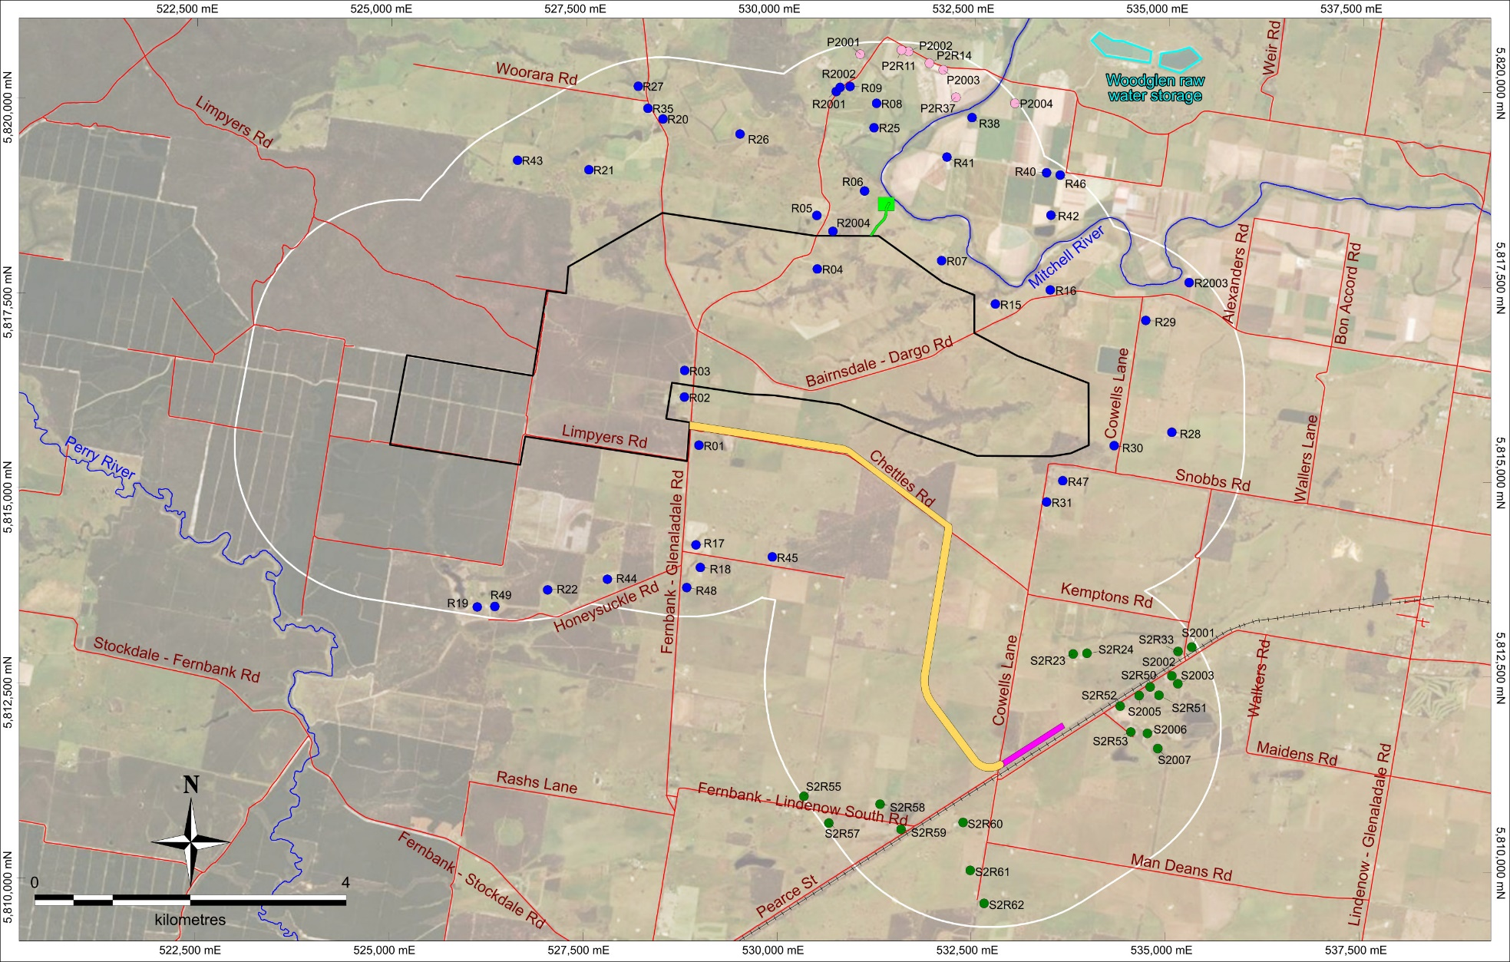
Figure 2.2: Sensitive receptor locations (dwellings)

Inherent risk
In this risk treatment plan ‘inherent risk’ means the likelihood and consequence of a risk event, assuming that standard controls specified in Attachment A of the Fingerboards Risk Management Plan are implemented.
Table 3-1: Inherent risk ratings – environmental noise [EPA Comment: should properly apply the New EP Act including the GED and provisions regarding “unreasonable noise” which include not only the noise level but also volume, intensity, duration, character etc (see s 3). Should properly apply the ERS and assess the environmental value of ‘human tranquility and enjoyment outdoors in natural areas’]
# | Details of risk event | Phase | Consequence | Likelihood | Inherent risk rating
1 | Noise levels at sensitive receptors exceed daytime or evening guideline values (Noise Protocol; Chapter 4 EPA Publication 1834, Civil construction, building and demolition guide) | C | Moderate | Unlikely | Medium
2 | Noise levels at sensitive receptors exceed night time guideline values (Noise Protocol; Chapter 4 EPA Publication 1834, Civil construction, building and demolition guide) | C | Moderate | Possible | Medium
3 | Noise levels at sensitive receptors exceed daytime or evening guideline values (Noise Protocol; Chapter 4 EPA Publication 1834, Civil construction, building and demolition guide) | O, CL | Moderate | Unlikely | Medium
4 | Noise levels at sensitive receptors exceed night time guideline values (Noise Protocol; Chapter 4 EPA Publication 1834, Civil construction, building and demolition guide) | O, CL | Moderate | Possible | Medium
5 | Noise levels at sensitive premises cause sleep disruption and / or loss of amenity | C, O, CL | Moderate | Possible | Medium
6 | Noise disrupts / displaces terrestrial fauna | C, O, CL | Insignificant | Possible | Low
7 | Vibration causes structural damage to private or public property | C, O, CL | Insignificant | Rare | Low
8 | Vibration adversely affects human comfort / amenity | C, O, CL | Minor | Unlikely | Low
Note: ‘C’ = construction; ‘O’ = operations; ‘CL’ = decommissioning and closure

Objectives
The objectives of this risk treatment plan are to minimise and manage project-related noise and vibration so as to: [EPA Comment: As per EPA’s cover letter the language across all of the risk treatment plans should be amended to reflect the intent of the New EP Act ]
- [EPA Comment: reference to the general environmental duty should be included]

- protect the health, wellbeing and amenity of residents and local communities
- protect the environmental values of the acoustic environment as defined in the Environmental Reference Standard.
- ensure compliance with the obligations under the EP Act 2017 and the EP Regulations 2021.
The controls described in this risk treatment plan aim to reduce noise generation from onsite activities and materials handling to the extent practicable.

Compliance standards
[EPA Comment: EPA recommends that this section and the “acceptance criteria” section 6 be amended to properly reflect the relationship between the New EP Act, the EP Regulations, the Noise Protocol, the ERS and the Construction Guideline. See amendments and further comments under section 6 below]
The main compliance standard for this risk treatment plan is the New EP Act and the EP Regulations 2021, including the ‘Noise limit and assessment protocol for the control of noise from commercial, industrial and trade premises and entertainment venues’ (EPA Publication 1826.4) (Noise Protocol) and the ERS,.
Where particular noise hazards are not covered by the Noise Protocol (for example, noise from construction activities), the New EP Act and the ERS continue to apply and guidance has been drawn from Chapter 4 of EPA Publication 1834, ‘Civil construction, building and demolition guide’ (Construction Guidelines).

Acceptance criteria
[EPA Comment: EPA recommends that this paragraph and Table 6-1 is amended to reflect the approach in the water risk treatment plan regarding the GED, but also to properly reflect the relationship between the New EP Act, the EP Regulations, the Noise Protocol, the ERS and the Construction Guideline. For example: the GED applies to all noise which may give rise to a risk of harm to human health or the environment (including unavoidable works). Section 3 and S166 regarding “unreasonable noise” of the New EP Act also apply to all noise (including construction noise). Noise assessed against the noise limits set in the EP Regulations (and determined using the methods in the Noise Protocol) is residual noise, once the GED has been complied with, they are not limits one can pollute up to and they are not design targets.]
Acceptance criteria are the measures which, if attained, are the basis for concluding that the control measures described in this plan have been effective in achieving the plan objectives. Noise criteria specified in the Noise Protocol, which set mandatory statutory limits, have been used as the main standard for defining acceptance criteria for noise generated within the mining licence area during the operations phase of the project. The acceptance criteria for this noise risk treatment plan are summarised in Table 6-1
Table 6-1: Acceptance criteria – noise and vibration
Standard | Acceptance criteria
Construction and demolition (closure) phase
EPA Publication 1834, Civil construction, building and demolition guide | - Day – Monday to Friday (7:00 a.m. to 6:00 p.m.) and Saturday (7:00 a.m. to 1:00 p.m.) there are no construction noise limits.  - Evening – Monday to Friday (6:00 p.m. to 10:00 p.m.), Saturday (1:00 p.m. to 10:00 p.m.) and Sunday / Public Holidays (7:00 a.m. to 10:00 p.m.) noise limit is to be no greater than 10 dB above background noise and outside a residential dwelling for the first 18 months, and no greater than 5 dB above background noise (at the time of impact) and outside a residential dwelling after 18 months.  - Night – Monday to Sunday (10:00 p.m. to 7:00 a.m.) noise must be inaudible inside a habitable room with windows open.  Construction noise that is audible inside a habitable room of a residence is permissible if approved by an independent environmental auditor as meeting the definitions of ‘unavoidable works’ and ‘low-noise or managed impact works’ in EPA Publication 1834 as per NV17.
 | [note that this conflicts with the criteria provided in the Construction Guidelines, as above, so preferable to delete]
Operations phase
Noise Protocol | - Day – 46 dB Leff (Monday to Friday (7:00 a.m. to 6:00 p.m.) and Saturday (7:00 a.m. to 1:00 p.m.)).  - Evening – 41 dB Leff § (Monday to Friday (6:00 p.m. to 10:00 p.m.), Saturday (1:00 p.m. to 10:00 p.m.) and Sunday (7:00 a.m. to 10:00 p.m.)).  - Night – 36 dB Leff (Monday to Sunday (10:00 p.m. to 7:00 a.m.)).
Notes: L_{eff} - Effective Noise Level. L_{eff} is the effective noise level of commercial or industrial noise determined in accordance with the Noise Protocol. L_{Aeq} – The equivalent continuous sound level, measured in dB, over the specified number of hours. This is commonly referred to as the A-weighted ‘average noise level’.

Controls to address hazard [refer to updated Mitigation Register, below superseded] [EPA Comment: EPA assumes that the third column “performance measures” in this table will remain in this risk treatment plan (despite not being shown in the Mitigation Register). EPA has sought and received a compare of Table 7-1 against the Mitigation Register (as there were differences). EPA will review that compare and provide any additional comments if necessary.]
Noise modelling for the construction phase of the Fingerboards project (Marshall Day, 2020) predicted that without proper mitigation, noise levels could exceed applicable noise criteria at some sensitive receptors within 1 km of the mining licence area boundary. Noise sources include both fixed and mobile noise sources. During operations, fixed noise sources include the wet concentrator plant, mining contractor’s workshop, truck loading, pumps and associated booster equipment. Mobile noise sources include all mobile construction equipment and plant used during the operation of mining unit plants transport of product. The noise sources with the greatest potential to impact noise-sensitive receptors will be the mobile plant, including mobile equipment used for the mining unit plants, tailings management or transport of heavy mineral concentrate. Table 7-1 lists the noise mitigation controls that will be implemented to limit impacts on nearby sensitive uses.
[EPA Comment: additional mitigation measures may be required to minimise the risk of harm to human health or the environment to the extent reasonably practicable. These additional measures may evolve overtime as the state of knowledge evolves]
Table 7-1: Environmental noise controls and associated performance measures
# | Details of controls | Performance measures
NV03 | When pumping units over 500 kVA are located within 800 m of any dwelling, temporary acoustic barriers will be used. Earth bunds, Echobarrier or FlexShield barriers would be appropriate as long as the barrier height exceeds the pump height by at least 0.5 m. The barrier system will incorporate an acoustically-absorptive finish to minimise reflected noise and will have a sound insulating rating over Rw+Ctr 22. | Barrier design specifications and as-built records.
NV06* | Contingency procedures will be implemented if noise emissions during construction are observed to exceed those modelled for this EES. Contingency measures may include short term, temporary relocation for noise-affected occupants, when high noise levels from construction occur at night and there are no feasible ways of reducing noise levels or re-scheduling the activity. | Noise monitoring records; complaints records
NV09a | A noise risk management plan will be prepared and implemented for the management of impacts on sensitive receptors in proximity of the project area. | Implementation of this plan; construction and operations works schedules developed in consideration of noise acceptance criteria
NV09b | Kalbar will implement a complaints management procedure to address (among other matters) noise-related complaints. | Complaints records and incident follow up
NV10 | Mobile plant items will be fitted with broadband reversing signals to avoid tonal characteristic associated with traditional reversing beepers. | Broadband alarms installed.
NV11 | Activities such as overburden movement will be restricted to day and evening periods during Year 1 to avoid noise propagation during the night. | Mine schedule; haulage records
NV12 | Screening measures through the construction of earth bunds at strategic locations to screen operational noise impacts upon sensitive receptors are an effective way to minimise noise impacts. | Construction records; noise monitoring records.
NV13 | Direct treatment through plant noise-reduction kits will be undertaken on mobile equipment over a tare weight of 35 tonnes. Suitable noise-reduction kits have been identified for specific items of plant in consultation with industry specialists (Hushpak and Minetek) and Kalbar. They are listed in Section 10.2.1 of the Noise and Vibration report supporting the EES. | Installation and maintenance records: noise reduction fittings installed; noise monitoring records at commissioning.
NV14 | The WCP will be cladded on the sides closest to sensitive receptors. The cladding will comprise 0.6 mm thick sheet steel with a lining of 75 mm thick, 32 kg/m2 glasswool insulation, which is expected to provide a sound insulation rating of Rw 31. The cladding will be applied to manage noise from the pumps and spirals. | Design specification; as-built records; noise monitoring records at commissioning.
NV15* | Consultation with affected residents located in the vicinity of the site will be conducted during the course of the project to investigate any need for alternative or additional noise control measures depending on each individual situation (e.g., acoustic treatment for dwellings, temporary relocation). | Consultation records; complaints records; attended and unattended noise monitoring records; implementation of agreed contingency actions.
NV16 | The quietest available plant and equipment will be selected for the project, where feasible. | Procurement specifications
NV17 | Noisier activities will be scheduled for less sensitive times where feasible and works will be limited as much as practicable during the night and weekends. | Construction and operations works schedules developed in consideration of noise acceptance criteria
NV18 | Residents at noise-sensitive receptors will be informed of the timing and location of each construction stage and associated noise reduction measures, and given notice and details of periods of noisy activities (such as excavation). | Records of communications with affected sensitive receptors
NV19 | Operational practices will be implemented (such as ‘push-back’ mining operations) to optimise the direction of pit excavation so the terrain provides maximum natural attenuation of plant and equipment. | Mine plan and schedule
NV20 | All personnel will be informed about the measures required to minimise noise including through regular toolbox talks. | Site inductions; toolbox talk records
NV22 | All pneumatic tools used near residential areas will be fitted with an effective silencer on the air exhaust port. | Periodic inspections by site environmental officer; work instructions
NV23 | Plant will be turned off when not in use. | Periodic inspections by site environmental officer; work instructions
NV24 | All plant and equipment will be maintained in accordance with manufacturers’ specifications. | Maintenance records
NV25 | No truck associated with the work will be left standing with its engine operating for more than five minutes, where possible. | Work instructions
NV27 | All project vehicles will be maintained in accordance with manufacturers’ specifications. | Maintenance records
NV28 | Trucks will be equipped with adequate and functioning mufflers. | Maintenance records
NV29 | Project vehicles will be driven to the speed limit and in a careful manner, avoiding strong acceleration/deceleration | Site inductions; work instructions; speed limit signs in place
NV30 | Activities which generate the highest potential noise and vibration will not be scheduled at night, where feasible | Construction and operations works schedules developed in consideration of noise acceptance criteria
NV31 | A permanent power supply will be secured as early as possible to minimise the time diesel generators are used. | Records of engagement with power provider; practical completion of permanent power supply
NV32 | Equipment and processes that do no exhibit characteristics of intermittency or impulsiveness will be selected, where feasible. | Procurement specifications
SE22 | Timely responses will be provided to any community complaints raised | Complaints records and incident reports / follow up records
SE26 | A community complaints procedure will be developed and implemented. | Procedure in plan and publicly available

Note: An asterisk (*) indicates an additional mitigation measure proposed to lower the risk of impact beyond what could be achieved using only standard mitigation measures.

Table 7-2: Additional Controls identified in the EES process.

# | Details of controls | Performance measures
1 | The centrifuge plant has been modelled without the benefit of the noise reduction associated with the proposed enclosure for the plant.  The design would need to be developed in further detail to provide a reliable basis for modelling the effect of the enclosure (to account for building configuration, material selections, and envelope penetrations). However, a basic lightweight enclosure with acoustically designed penetrations would reduce the noise of the centrifuge plant by at least 5 dB, and alternative material selections including demountable insulation panels would readily enable enclosure reductions of at least 15 dB.  This will be addressed during detailed design. Detailed design will consider the requirement to reduce noise emissions including cladding and enclosures. | Detailed design that meets noise criteria through better modelling assumptions
2 | Irrespective, if the centrifuge-based option is developed, all aspects of the centrifuge plant, including the building design, associated ancillary equipment and associated haul route changes, would need to be represented in the design stage noise modelling. Consistent with the wider approach to addressing noise from the site, this design stage modelling would inform:  The specification and tendering of equipment to meet the noise requirements  The development of the noise mitigation and management measures will be incorporated into this Environmental Noise Management Plan. | Updated noise risk treatment plan to incorporate detailed design elements of the project.
3

Residual risk assessment
The risk ratings for events contributing to environmental noise hazards – once standard and additional mitigation actions have been put in place – are summarised in Table 8 1.
Table 8-1: Residual risk ratings – environmental noise [EPA Comment: Again needs to properly apply the New EP Act including the GED and provisions around “unreasonable noise” which include not only the noise level but also volume, intensity, duration, character etc (see s 3)]
# | Details of risk event monitored | Phase | Consequence | Likelihood | Residual risk rating
1 | Noise levels at sensitive receptors exceed daytime or evening guideline values (Noise Protocol; Construction Guidelines) | C | Unlikely | Minor | Low
2 | Noise levels at sensitive receptors exceed night time guideline values (Noise Protocol; Construction Guidelines) | C | Unlikely | Moderate | Medium
3 | Noise levels at sensitive receptors exceed daytime or evening guideline values (Noise Protocol; Construction Guidelines) | O, CL | Unlikely | Minor | Low
4 | Noise levels at sensitive receptors exceed night time guideline values (Noise Protocol; Construction Guidelines) | O, CL | Unlikely | Moderate | Medium
5 | Noise levels at sensitive premises cause sleep disruption and / or loss of amenity | C, O, CL | Unlikely | Moderate | Medium
6 | Noise disrupts / displaces terrestrial fauna | C, O, CL | Possible | Insignificant | Low
7 | Vibration causes structural damage to private or public property | C, O, CL | Insignificant | Rare | Low
8 | Vibration adversely affects human comfort / amenity | C, O, CL | Unlikely | Unlikely | Low
Note: ‘C’ = construction; ‘O’ = operations; ‘CL’ = decommissioning and closure

Monitoring
[EPA Comment: EPA recommends similar wording to that used in the water risk treatment plan and repeats its comment that corrective actions should be documented now]
Monitoring required to check the effectiveness of noise controls is summarised in Table 9-1.
Table 9-1: Proposed monitoring for environmental noise
# | Aspect to be monitored | Details of monitoring
1 | Noise emissions testing (targeted commissioning checks of fixed and mobile plant) | Noise testing of selected fixed and mobile equipment at commissioning / start of construction to confirm that actual plant noise levels conform to design specifications and are in line with the noise data that were input in the noise model and to check whether operations can be implemented in a way that is consistent with obligations under the New EP Act and the EP Regulations 2021. [EPA Comment: As above, should reflect that the GED and s3 and s 166 applies to all noise]
2 | Noise emissions testing (targeted follow up checks of fixed and mobile plant) | Annual noise testing of selected fixed and mobile equipment at to check that actual noise emissions levels conform to design specifications and are in line with the noise data that were input in the noise model.
3 | Ambient noise – attended monitoring (project commencement) | Attended monitoring of ambient noise during construction phase of the project. Measurements would be undertaken during day, evening and night periods to determine the noise level due to site construction activity at the worst-affected noise-sensitive receivers. Location and duration of monitoring to ensure representative monitoring.  [specifying 3 days too specific and also likely to be insufficient – plus does not account for deployment of continuous remote noise monitoring equipment which will often be in place for 14 days or more]  [limitation to ‘first 14 days’ insufficient. Monitoring will need to be tailored to construction schedule and when impacts may arise]
4 | Ambient noise – attended monitoring (construction surveillance) | Follow up attended noise monitoring – at least 2 monthly during the construction phase of the project with additional measurement campaigns which are fit for purpose. Measurements would be undertaken during day, evening and night periods to determine the noise level due to site construction activity at the worst-affected noise-sensitive receivers.
5 | Ambient noise – attended monitoring (mining operations) | Follow up attended noise monitoring as necessary to demonstrate compliance with obligations under the New EP Act and the EP Regulations 2021 based on worst case operations  [yearly measurements is too simplistic. Needs to be targeted and likely more frequent than once yearly]
6 | Ambient noise – unattended monitoring (project commencement) | At least 7-day unattended surveys conducted during the first three months following commencement of operation (one survey per month during each of first three months or additional measurements as needed to properly assess compliance). Measurements would be undertaken during day, evening and night periods to determine the noise level due to site construction activity at the worst-affected noise-sensitive receivers.
7 | Ambient noise – unattended monitoring (ongoing monitoring). | At least 7-day surveys conducted quarterly following commencement of mining (one survey per quarter or additional measurements as needed to properly assess compliance). Measurements would be undertaken during day, evening and night periods to determine the noise level due to site construction activity at the worst-affected noise-sensitive receivers.
8 | Complaints | Continuous monitoring, assessment of and response to complaints in accordance with Fingerboards Complaints Procedure. [EPA Comment: Unsure what the “Fingerboards Complaints Procedure” states but as per EPA’s original submission EPA recommends targeted noise emissions testing is conducted in response to complaints]  If a noise complaint occurs outside of scheduled noise monitoring periods, the noise complaint would be investigated by reviewing the record of site activities. If noise from site activity is confirmed to be the cause of the complaint, and if the site activity records are not sufficient to determine the reason for the noise, further noise monitoring may be undertaken outside the scheduled noise monitoring periods.
9 | Meteorological conditions | Continuous monitoring of temperature, humidity, wind speed and direction, barometric pressure, precipitation.

Reporting
Table 10-1: Noise performance and compliance reporting
# | Aspect being reported |  | To whom will the information be reported? At what frequency? | How will the information be used?
1 | Noise emissions testing (targeted commissioning checks of fixed and mobile plant). | Event based-reporting to environmental superintendent; non-conformance reporting to contracts manager. |  | To review and update predict noise modelling; as basis for acceptance of plant and equipment; to inform procurement practices.
2 | Noise emissions testing (targeted follow up checks of fixed and mobile plant) | Event based-reporting to environmental superintendent; non-conformance reporting to contracts manager. |  | To review and update predictive noise modelling; as basis for acceptance of plant and equipment; to inform procurement and maintenance practices.
3 | Ambient noise – attended monitoring (project commencement) | Event based-reporting to environmental superintendent and construction manager. |  | To check effectiveness of personnel inductions, complaints management procedure; to check compliance with Construction Guidelines.
4 | Ambient noise – attended monitoring (construction surveillance) | Monthly reporting to Fingerboards management team; quarterly reporting to Community Reference Group; annual environmental compliance reporting to ERR, EPA and EGSC. |  | To check compliance with Construction Guidelines; input to contractor performance assessment.
5 | Ambient noise – attended monitoring (mining operations) | Monthly reporting to Fingerboards management team; quarterly reporting to Community Reference Group; annual environmental compliance reporting to ERR, EPA and EGSC. |  | To demonstrate compliance with the New EP Act and the EP Regulations 2021; input to review and update predictive noise modelling; input to updates of this risk treatment plan; to inform mine planning and maintenance schedules.
6 | Ambient noise – unattended monitoring (project commencement) | Monthly reporting to Fingerboards management team; quarterly reporting to Community Reference Group; annual environmental compliance reporting to ERR, EPA and EGSC. |  | To check compliance with Construction Guidelines; input to contractor performance assessment.
7 | Ambient noise – unattended monitoring (ongoing monitoring). | Monthly reporting to Fingerboards management team; quarterly reporting to Community Reference Group; annual environmental compliance reporting to ERR, EPA and EGSC. |  | To demonstrate compliance with New EP Act and the EP Regulations 2021; input to updates of this risk treatment plan; input to review and update predictive noise modelling; to inform mine planning and maintenance schedules.
8 | Complaints | Weekly reporting to Fingerboards management team; complaints statistics reported quarterly to Community Reference Group; annual reporting to ERR and EPA. |  | To check effectiveness of noise control; to inform ongoing mine planning, maintenance and monitoring strategies
9 | Meteorological conditions | Daily reporting to environmental superintendent; event-based reporting to management team in the event of complaints or non-compliance events. |  | To inform incident investigations; input to predictive noise modelling.

References[EPA Comment: should be updated to reflect EPA’s comments in section 5 and 6 of this RTP]
Ecology and Heritage Partners, 2019. Detailed Ecological Investigations for the proposed Fingerboards Mineral Sands Project, Glenaladale, Victoria, September 2019.

EPA Publication 1826.4, Noise limit and assessment protocol for the control of noise from commercial, industrial and trade premises and entertainment venues (Noise Protocol)
EPA Publication 1834, Chapter 4, Civil construction, building and demolition guide (Construction Guidelines)
Kalbar Operations Pty Ltd, 2020. Fingerboards Mineral Sands Environmental Effects Statement.
Marshall Day Acoustics, 2020. Fingerboards Mineral Sands - EES Noise and Vibration Assessment, Report No 001 R07 02Draft 20170182, April 2020.

Kalbar reference documents

[To be completed when EMS is fully developed]
Table 12-1: Kalbar reference documents
# | Document
1
2
3

